Tab 1
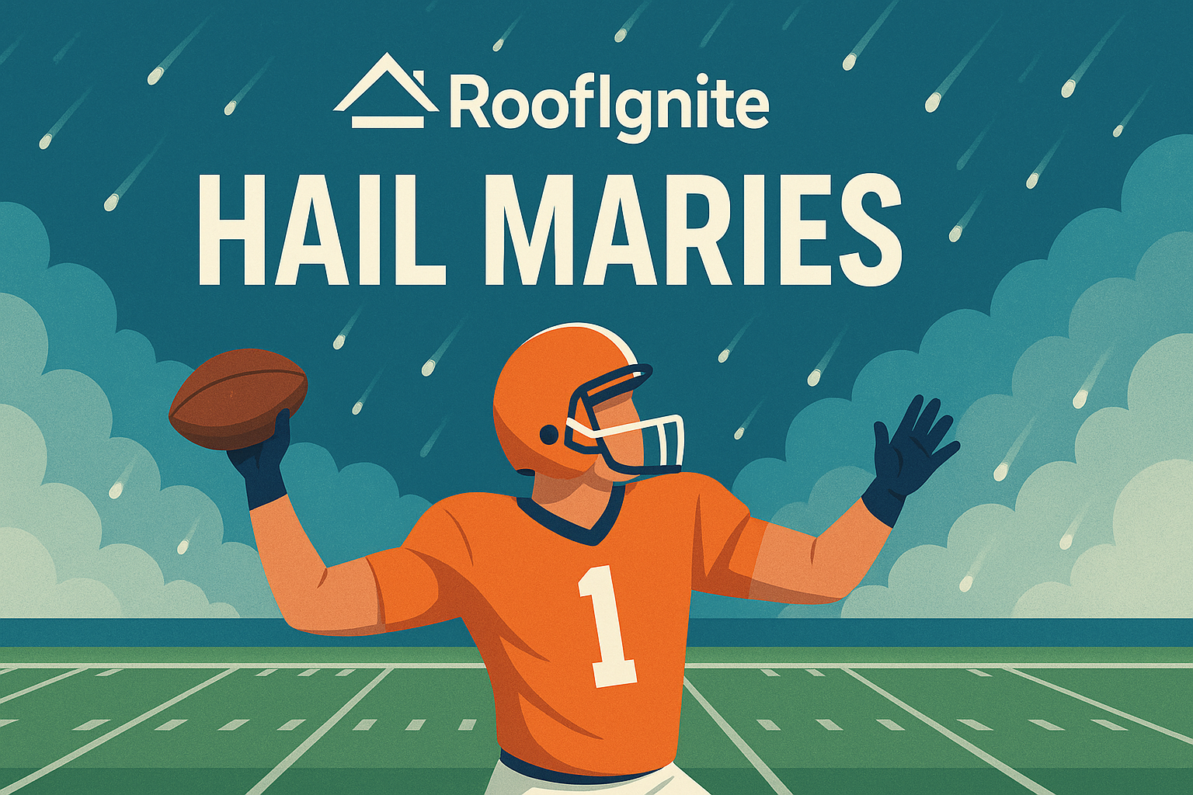
A History of RoofIgnite “Hail Mary” Actions
WHAT IS THIS DOC?
This document has been created to showcase “hail mary” (last resort) actions that were taken and which successfully turned a struggling account into a successful account.

The purpose of this document is for present and future success partners to gain perspective from “hail mary” actions that resulted in account turnarounds. The goal is for readers to gain actionable insight from situations similar to the ones they’re facing

FORMAT
ACCOUNT:
STATE:
DATE:
ISSUE(S):
ACTION(S) THAT DIDN’T WORK:
ACTION(S) THAT DID WORK:
MAGNITUDE OF SUCCESS:

LIST OF HAIL MARIES
ACCOUNT: Roof Guard LLC
STATE: Nebraska
DATE: 10/11/2025
ISSUE(S):
- Extremely low survey rate
- Low lead volume
- Bad layer 1 metrics overall despite generally good layer 2 metrics
ACTION(S) THAT DIDN’T WORK:
- 60% creative refresh with b-tier creatives
- Going from 7q to 3q form
- Change from KNOW to KNOWv2 copy
ACTION(S) THAT DID WORK:
- 100% creative refresh with 3+ smiling selfie pics
- Took a look at the locale, asked if their team would be willing to add the city of Omaha (+200k audience) which was 1hr 15m from HQ- They agreed. Omaha was added to targeting and a secondary funnel was created.
MAGNITUDE OF SUCCESS:
- Immediate uptick in booking rate (2/day)
- Survey rate in both demographics surged to within KPI band

—————————— ✦ ——————————

ACCOUNT: US Shingle Manatee/Sarasota
STATE: Florida
DATE: 11/22/2025
ISSUE(S): Low, low lead flow (ads are the issue)
ACTION(S) THAT DIDN’T WORK: Adding custom andromeda video content
ACTION(S) THAT DID WORK: Dialing in on the psychological cues, going back and looking at top performing static ad creatives and replicating those styles (modelling the setup for single/two-fold/tri-fold). And the biggest detail was l hid the local cues because this client only could get me creatives in Tampa/Hillsborough county, and houses don’t look the same so I only picked images that looked like they could be in Manatee/Sarasota
MAGNITUDE OF SUCCESS:
- 2345 spent to get 4 bookings prior to that change
- 1005 spent to get 4 bookings after change
- MASSIVE

—————————— ✦ ——————————
Arsenal:
-AI - put fake AI people inside of the static roof images that don’t have people

Florida Accounts
What Turned Florida accounts around?
Florida Roofing and Gutters – St. Pete
Why performance is strong right now

1. Creative angle is doing the heavy lifting
The top performing creative is the price anchoring hook:
“$12,000 for a roof in Tampa & St. Pete? Seems really average.”
This works because it:
- Immediately qualifies homeowners by budget
- Anchors expectations around realistic pricing
- Filters out low intent price shoppers before the click
- Sparks curiosity and debate which boosts engagement
You can see this reflected in:
- Strong engagement on the post (likes comments shares)
- Higher CTR compared to other creatives
- Cheaper CPC relative to other ads in the set
This is not a generic roofing ad. It’s opinion based pricing education, which Florida homeowners respond very well to.

2. Trust heavy visuals
The winning creative uses:
- Real crew members
- Real homeowners
- On site photos
- Aerial finished roof shot
This combo hits:
- Social proof
- Legitimacy
- Scale perception
It feels like a real local company, not an ad agency build. This is especially important in Florida where homeowners are skeptical due to storm chasers.

3. The clear winner inside the ad set
From the ads view over the last 30 days:
- 52Grid
  - 12 website schedules
  - Cost per schedule ≈ $143
  - Spend ≈ $1,715
  - Frequency 1.65 (healthy not fatigued)
  - Reach 23K+
- 55Grid New Creative
  - 6 website schedules
  - Cost per schedule ≈ $59
  - Much lower spend
  - Very strong efficiency early
Everything else in the ad set has either:
- No conversions yet
- Very low spend
- Or is still being tested
Key insight:
Performance is being carried by 2 pricing education creatives, not volume of ads.

4. Ad set structure matters
- Single campaign
- Single ad set
- Multiple grid style creatives
- $75 daily budget per ad
- Frequency still under 2 across winners
This allows Meta to:
- Quickly find winners
- Shift spend naturally
- Avoid audience fatigue
Nothing fancy. Clean structure. Letting Meta do its job.

5. Traffic quality confirms intent
From the metrics screenshot:
- CTR all up to ~3.7 percent on winning ads
- CPC all as low as ~$1.20 on best performers
- Landing page views concentrated on the same ads that are producing schedules
This confirms the ads are:
- Pulling the right homeowner
- Not just cheap clicks
- Actually converting downstream

AQS

What’s Working for AQS (per Jonathan)
- Lead flow issue was fixed
Previously, AQS was not generating leads correctly. That issue has now been resolved, and leads are coming in again.
- Focus has shifted from lead volume to conversion
Now that leads are flowing, the priority is ensuring those leads convert into booked appointments, not just form fills.
- System correction before scaling
Jon emphasized fixing the core funnel and lead handling first, rather than scaling spend too early. The account is now in the “optimize and validate” phase.
- Next step: verify lead quality → booking rate
Ongoing work is focused on confirming that:
  - Leads are legitimate
  - They are being contacted properly
  - They are converting into appointments at an acceptable rate

